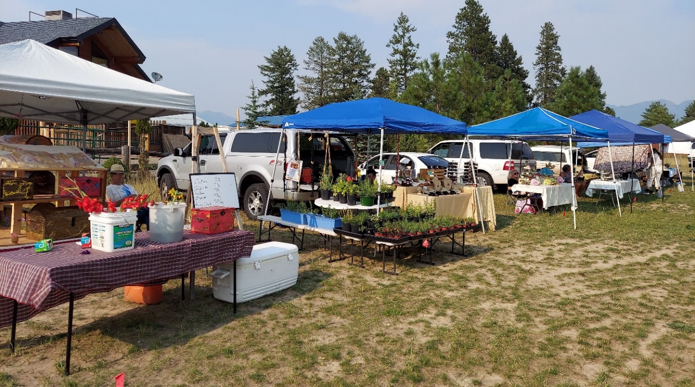
Bigfork Farmers’ Market 2021 Annual Report
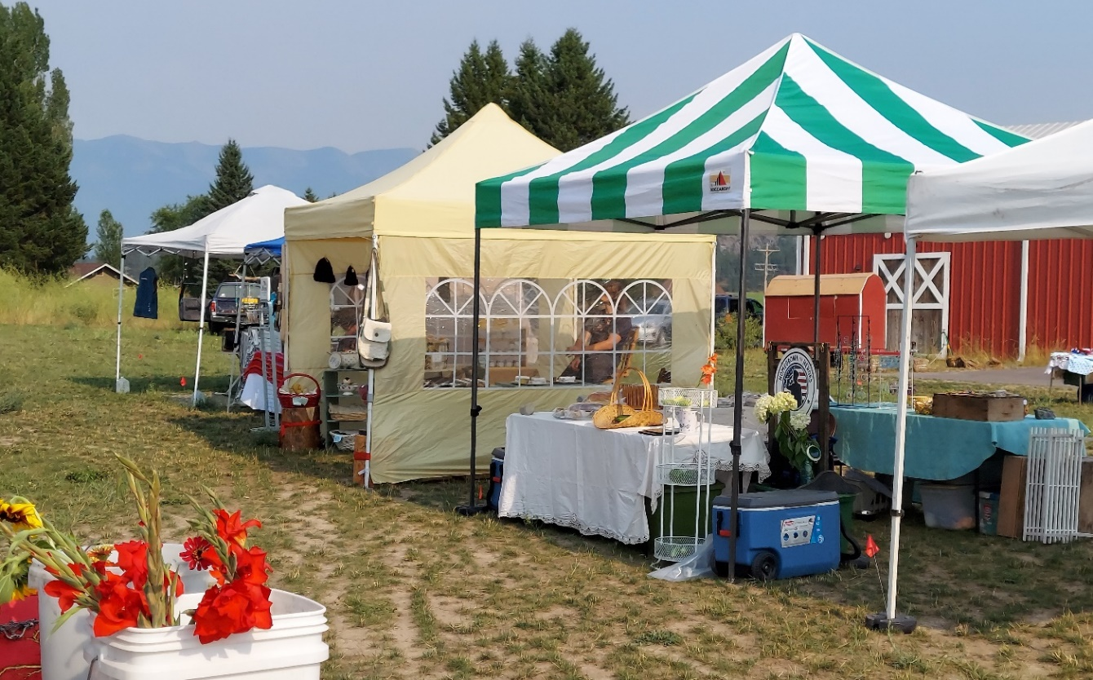
Letter from the President:

Twelve years ago, the Bigfork Farmers’ Market (BFFM) Cooperative began as a group of vendors sharing ideas and resources. With support from a steadfast group of Directors, BFFM has grown into a diverse network of farmers, crafters and artisans that is still growing. Your actions, support and engagement have made our community farmers’ market possible. Thank you for your partnership. While the year also presented more than its share of challenges, we strive on, empowered by the shared mission that forged BFFM a dozen years ago: to build a brighter future for farmers, crafters, artisans, consumers, and communities.

For our Co-op members; past and present and the vendors, 2021 continued to be a challenge for all those involved. With Covid-19 still prevalent and climate change creating complications through changes in seasonal temperatures we had much to overcome. Through hard work and dedication our farmers’ market continued to demonstrate how vital we are to the community through the people who grow, raise, harvest, bake and make the goods we supply throughout the market season. The BFFM board and staff along with member’s families, vendors, shoppers and supporters continue to step up with our shared belief in the critical importance of local food, protection of local food systems and supply chains and local economies.

We are grateful that we have been able to continue to serve our community and Flathead Valley in helping sustain the local food system during 2021 - and for all the partners, customers, and families who supported us along the way. BFFM is so lucky to have such a committed, talented board and great supporters, and 2021 was no exception. Onward to 2022 as farmers’ markets continue to rise up as an incredible force for change.
With gratitude,

Jodi Fee, President / Market Manager
Bigfork Farmers’ Market Cooperative

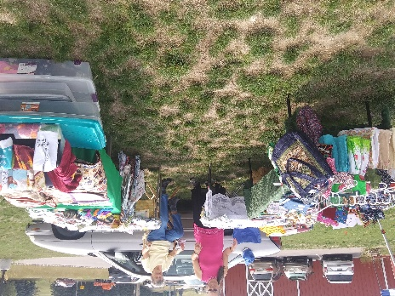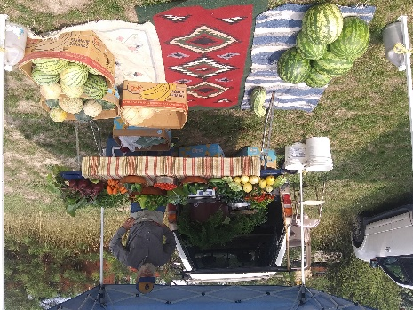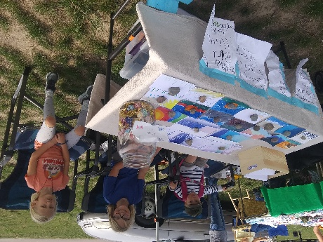

To our Shareholders,
We have a passionate and purpose-driven team here at the Bigfork Farmers’ Market, and it has been an incredible privilege to lead a company rooted in improving the health of the communities it serves. Our success would not be possible without our team members’ devotion, passion, and hard work. I am incredibly proud of how our teams came together to improve access to healthy food across the community. Over the last decade, we have remained true to our farm-stand heritage by providing a distinguished shopping experience with an assortment of healthy food and good-for-you options as well as locally hand made products.

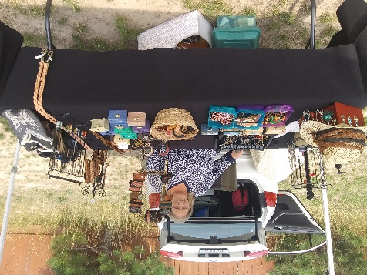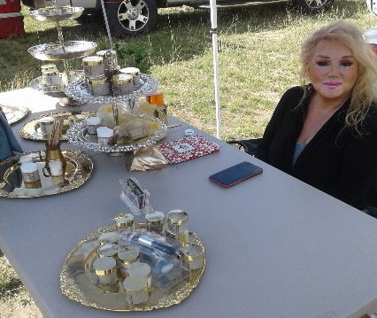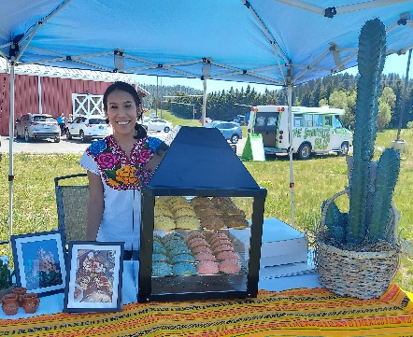
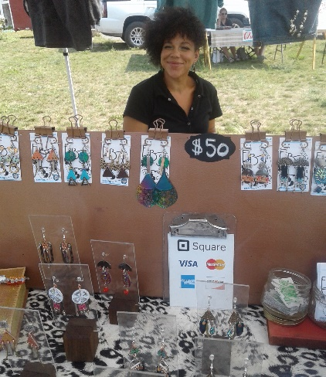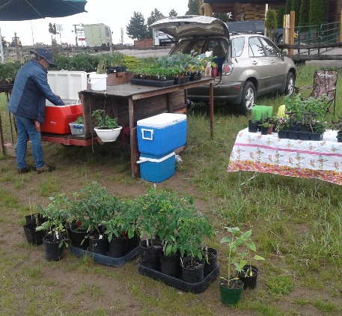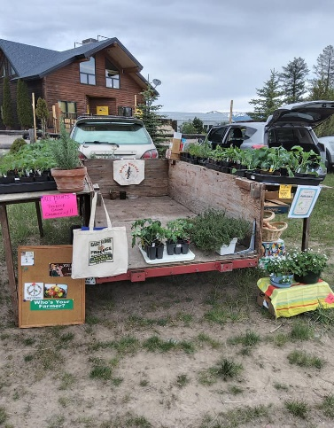
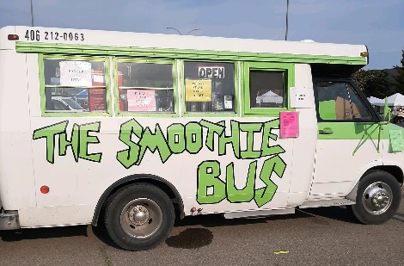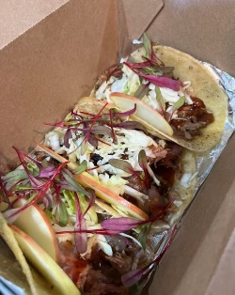
S & M Taco Truck
Board of Directors
Much like the shifts we’ve seen elsewhere in the last year, 2021 also marked a year of change at BFFM. A big thank you to our previous Board Directors: Jackie McCoy, Justine (JJ) Dynneson and Ruby Dynneson, who completed their terms at the end of 2021 and have moved on to new chapters.
We would like to extend our heartfelt gratitude for Jackie, JJ and Ruby for their dedication and contributions to the farmers’ market over many years.

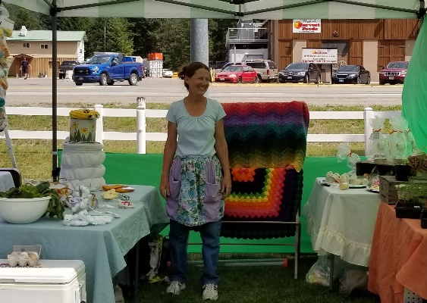 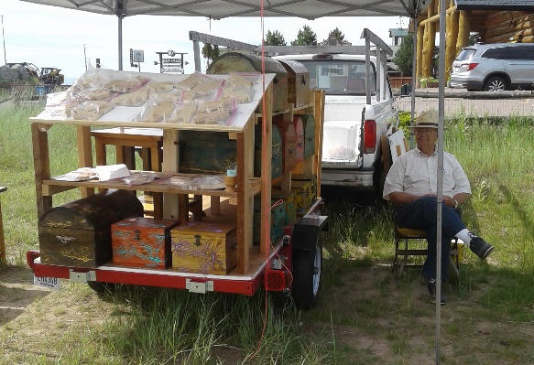
President: Jodi Fee Vice President: Paul Strong
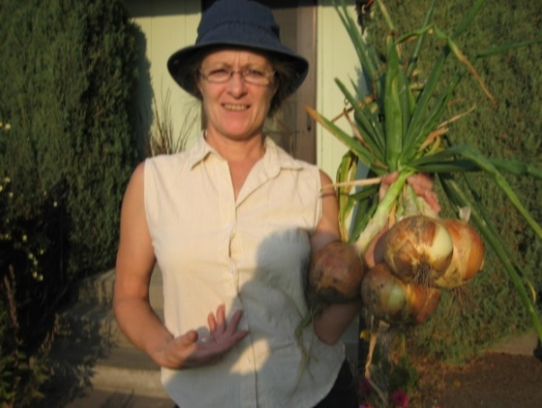 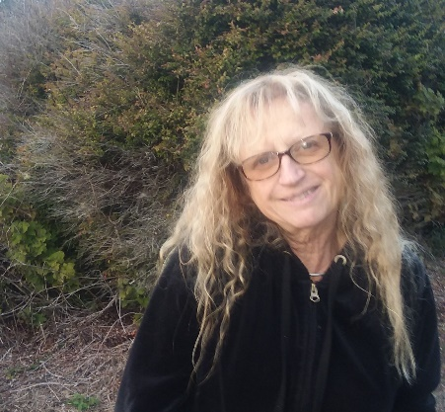
Secretaries: Jackie McCoy and Cathi Norris
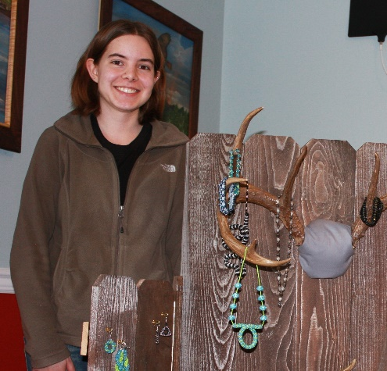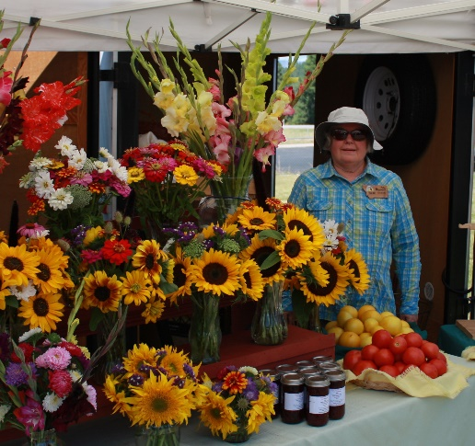
Treasurer: Justine Dynneson Director at Large: Ruby Dynneson
Director at Large: Helen Tobiason
Volunteers
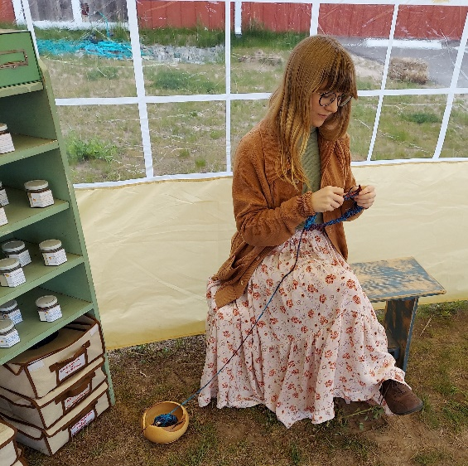
Social Media: Kassie Cumming Website: Ian Fee

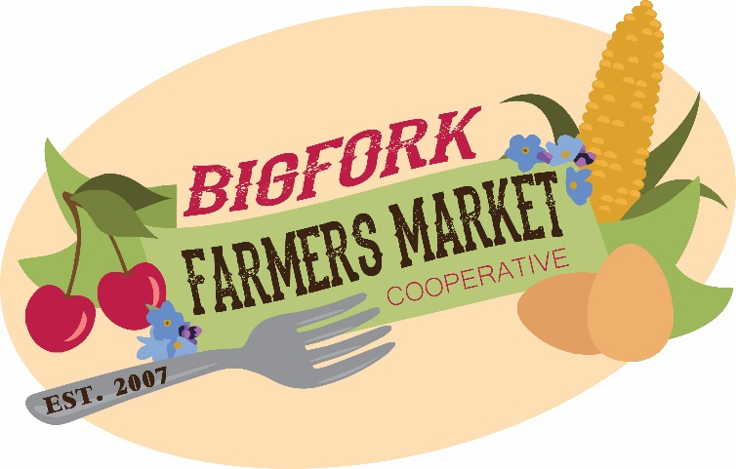
WE ARE PASSIONATE
ABOUT SUPPORTING
FARM, FOOD AND ARTISANAL
BUSINESSES TO GROW SO LOCAL FOOD SYSTEMS AND OUR COMMUNITY CONTINUES TO THRIVE

Sowing Growth
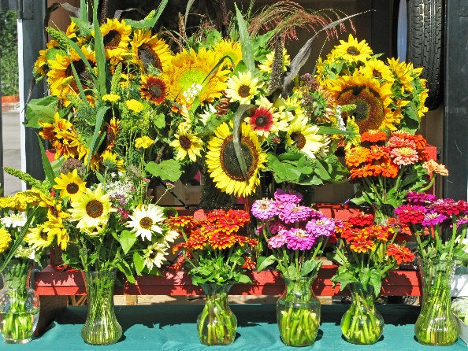
Plant a seed and watch it grow...
2021 appeared to be the beginning of a dream realized for many BFFM vendors, staff, and partners who have worked hard behind the scenes for years. From record-setting crowds, to unprecedented vendor sales, the vision long held by a small group of vendors in a gravel parking lot decades ago has started to take shape. We’re excited about all that is still to come as the market continues to grow, but in the meantime, here’s our year in review:

Our Roots
We provide equitable food access, direct from the farm food products, prepared foods, and crafts. FRESH * LOCAL * HEALTHY
With incredible heart and commitment, our members were able to come together in one way or another; growing stronger in tandem with the demand and support for local food and products. Thank you to all Co-op members and vendors for your hard work in continuing to strengthen our local food system and local economies safely. The Bigfork Farmers’ Market will continue to actively listen and provide what is needed to strengthen our market for years to come.
Continuing to build our vendor selection is key to the success and growth of the Market. In 2021, we welcomed 7 new and 17 returning vendors totaling 24. This increase in vendors resulted in an all-time high of 21 vendors at our June 30th Market! They brought their products from their farms, kitchens, craft rooms and workshops. They sold fruits, vegetables, honey, flowers, bread, baked goods, preserves, jewelry, leather goods and crafts. Additions to the Market included more wood crafts, gluten free baked goods, beeswax products, personal care items, new ready-to-eat food vendors, lemonade and smoothies.
Welcome to our new Farmers’ Market Members and Vendors in 2021!
Bee’s Knees ‘n’ Knits – became a Co-op member!
Emily Brooks – became a Co-op member!
Jacquie Simmons
Marley and Me – became a Co-op member!
Nathanial and Mara Hazekamp – became a Co-op member!
Shauna Gibson
Terri Aldrich
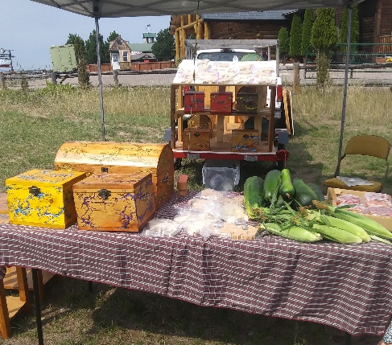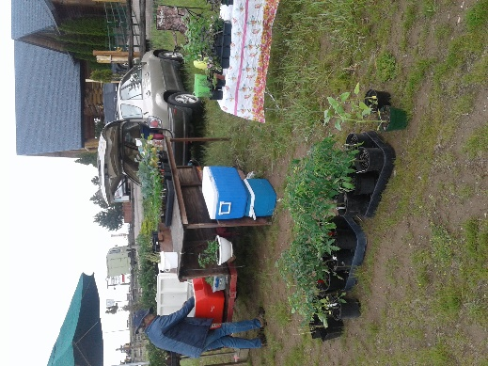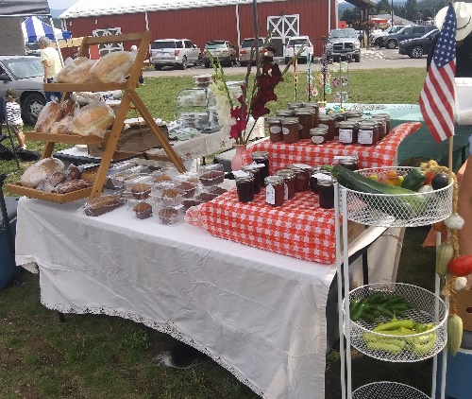
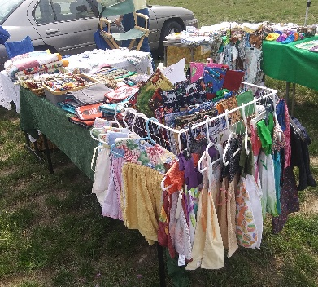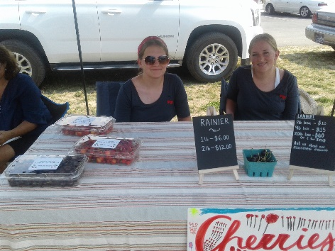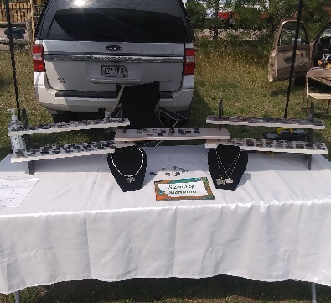
We look forward to seeing you again this year!
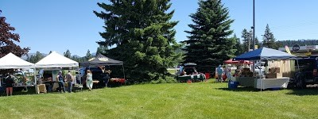 "We had a very good year. As we have expanded operations in 2021, it is hard to compare with prior years, but in general our sales were very strong; we sold out of our early season products (plants) sooner than in prior years." - Vendor Member

CUSTOMER COURNER
I always appreciate the amazing produce, friendly faces, and great conversations I have with the community at the Bigfork Farmers’ Market. I end up spending most of my time talking and laughing with amazing people, getting recipes or cooking tips, and listening to live music. – Barry

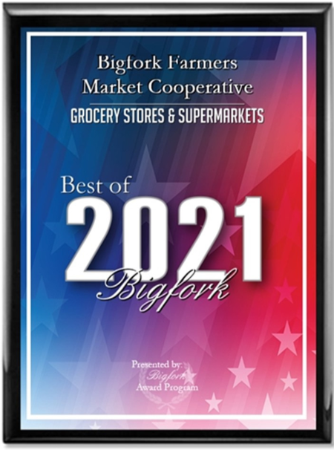
Our family loves the Bigfork Farmers Market. It’s our toddler’s favorite afternoon activity. Wednesdays we just have to go and get banana bread and a smoothie, then we head over to listen to the band play. I am so grateful the Bigfork Farmers’ Market is in our community. – Donna

“I love it. It is one of the greatest joys of my week. I am so thankful for all the people who make it happen and grow.” - Susan

Happenings at the Market
The market continued to thrive in 2021 with added events such as a free lettuce starts give-away on opening day, the raffle of a youth Kayak for the 4th of July and several live bands. All bands and soloist are volunteers and entertain all of us for the tips they receive.
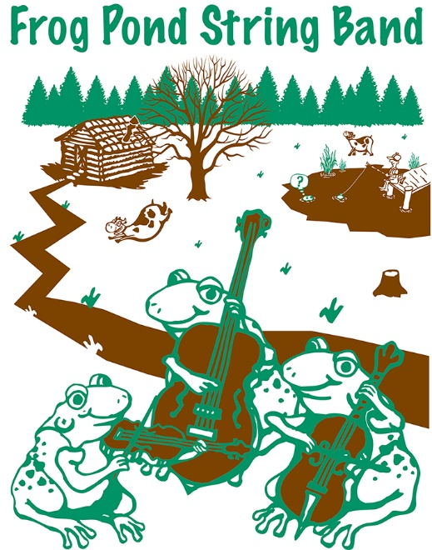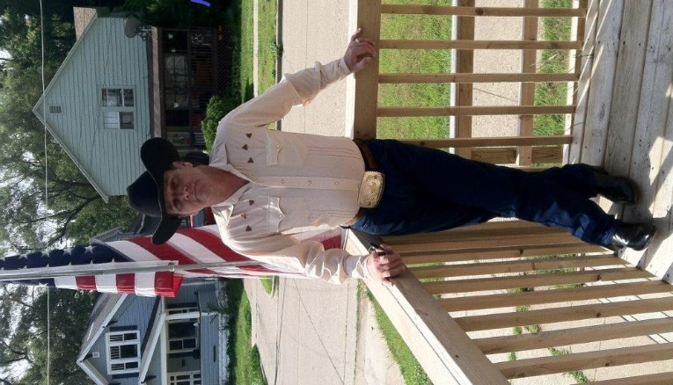
Frog Pond String Band Alan Nash - Soloist
Bands provide what music does best, build a sense of community, sharing, and a feel-good vibe. You’ll be with kindred spirits who appreciate both good food and good music!
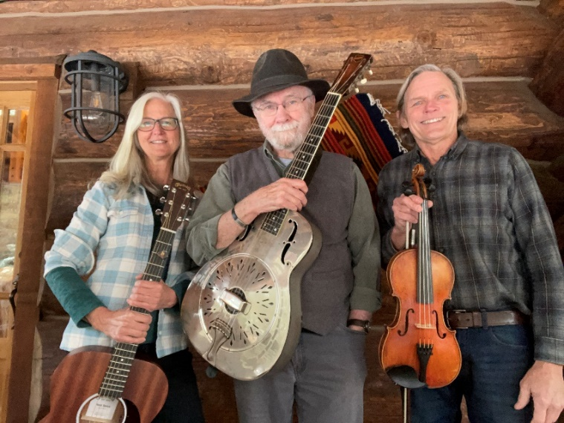
Rocky Mountain High Band
All these events will be continued in 2022 with more giveaways’, raffles and live entertainment!
Financials
Bigfork Farmers’ Market Cooperative is a not-for-profit Cooperative that derives its’ income from vendors fees, raffles, events, donations and sponsors. As such BFFM does not ask vendors for a percentage of their sales nor relies on outside sources. We continue to be in a solid financial position and anticipates growth in the years to come.

2021 End of Year Treasurer’s Report
2020 Beginning Balance $1339.42 2021 Beginning Balance $847.63
Income: 2020 2021
Common Stock $0.00 $80.00
Market Fees $660.00 $965.00
Raffles $0.00 $40.00
Donations $0.00 $35.00
Expenses:
Post Office $156.00 $156.00
Advertisement $467.79 $135.77
Website $204.00 $323.70
Insurance $144.00 $426.00
Bank Fees $0.00 $0.00
Taxes $180.00 $192.80
2020 Ending Balance $847.63 2021 Ending Balance $733.36

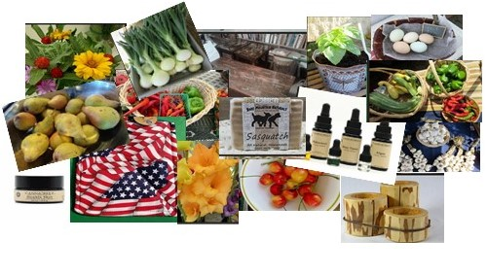

Contact Us
Phone: 406-871-1554
Email: bffm@bigforkfarmersmarket.com
Address: 439 Grand Ave Suite 213
Bigfork, MT 59911
Website: bigforkfarmersmarket.com
Facebook: Bigfork Farmers Market Co-op
Instagram: @Bigfork.coop

